CS136 Lab Section 1
Joshua Pollock & Tyler Smith
February 7, 2017

Drawing Blocks - Lab 02

Problem Statement
The problem given by the lab was to create a program which would use Graphics2D and a JFrame to draw various “Tretris” styled blocks. These blocks are not required to fall like in the actual falling block puzzle game, but only need to be drawn in a JFrame. The resulting program output should look like this:
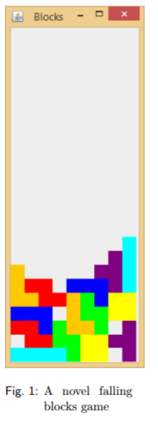

Constraints:
- The output must be displayed in a legal arrangement.
- Each block should align with the others and must be resting at the bottom or resting on another block
- JFrame must be 10 squares wide
- Each block has a unique color to it
  - I Block: Cyan, J Block: Blue, L Block: Orange, O Block: Yellow, S block: Green, Z Block: Red, and T Block: Purple (Magenta in our case).
- Each square must be drawn at least twice
- We may not create more rectangles for the same blocks/drawings
  - 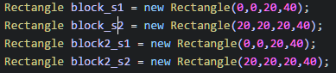

Assumptions:
- Must use Graphics2D to create rectangular blocks
- Use Graphics2D object (g2d) with fill, setColor, and rotate to position and color blocks
- Must allow paintComponents/Graphics2D components to be callable in the viewing program

Features:
- JFrame
- g2d.setColor
- g2d.scale
- g2d.fill
- g2d.translate
- g2d.rotate
- new Rectangle (0,0,60,20); - one example
- AffineTransform example=g2d.getTransform();

Planning:
Planning our approach to the problem at hand took some time. We needed to figure out how to draw the different shapes of rectangles, fill them, and set them to specific locations in the JFrame. The JFrame would need to be created in a separate class from the components class. Then setting up each new block would be created using setColor, translate, fill, rotate, and setTransform in ‘protected void paintComponent(Graphics g)’, to create different colored and shaped blocks that were described by the lab instructions.

Implementation:
We began implementing our code by first brainstorming what we wanted to occur inside of the code. After consulting with each other we began to start putting the code inside of a .java file. We started with the easier of the two classes, the BlocksViewer class. Here, we set up a JFrame that would be used to display our result. We used ‘BlocksComponent component = new BlocksComponent();’ and ‘frame.add(component);’ to eventually add the block components to the JFrame.

In the BlocksComponent class we started by creating each block as a new rectangle. Once these were created, we could easily move them around into the required positions by using .translate(x), .scale(x,y), and .rotate(Math.toRadians(x)). Reading the lab requirements gave us the colors for each of the created blocks and using the .fill(x) command we could fill in each block.

Running Application:

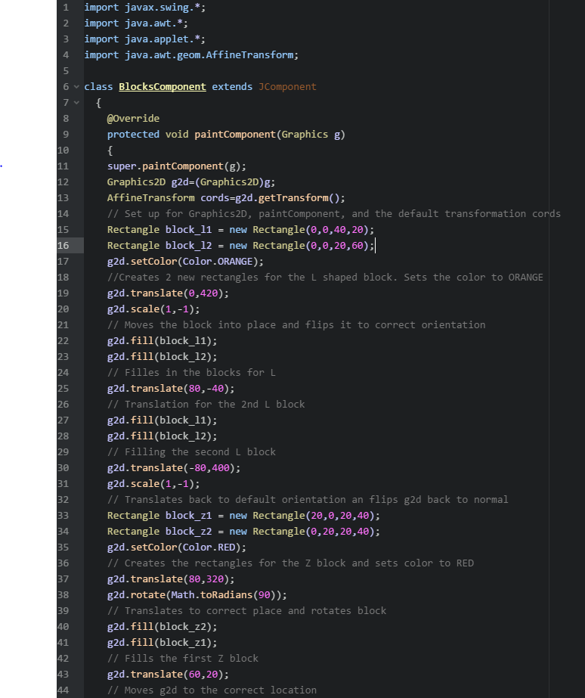
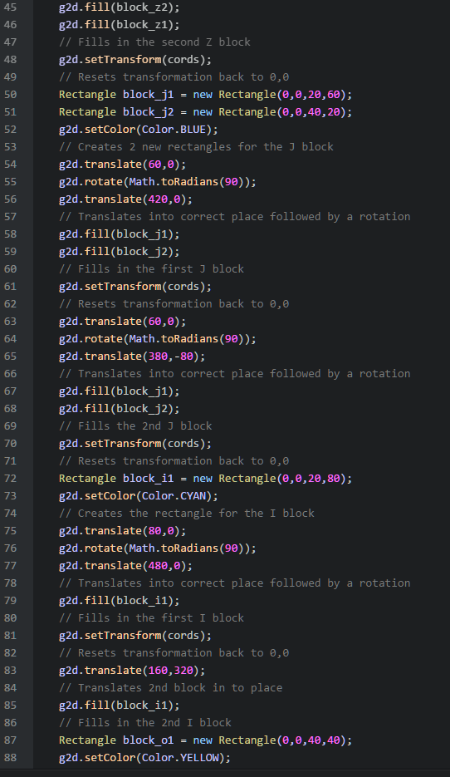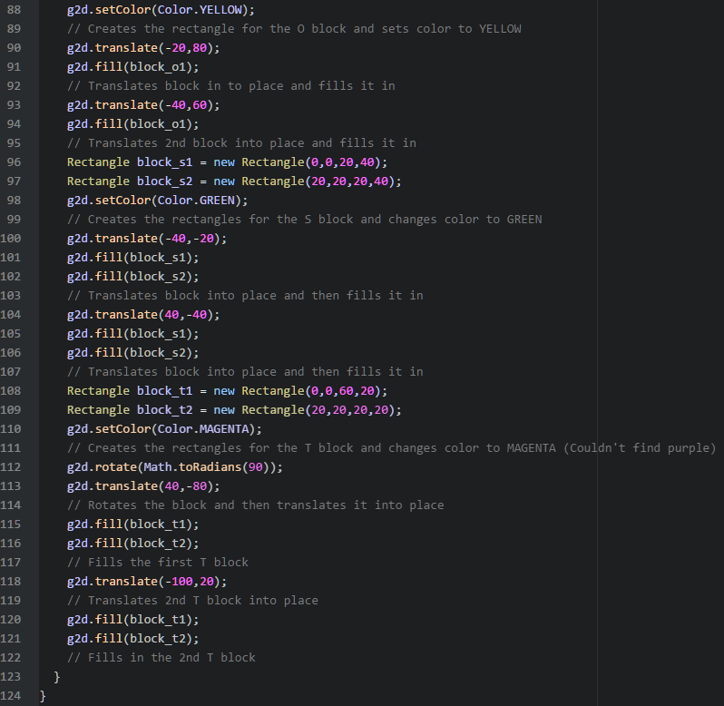

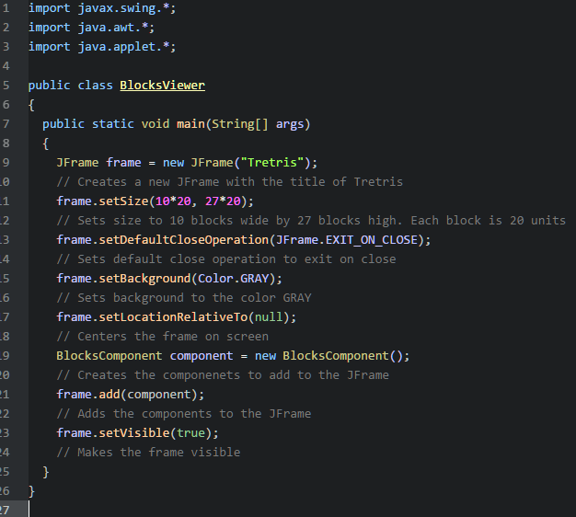

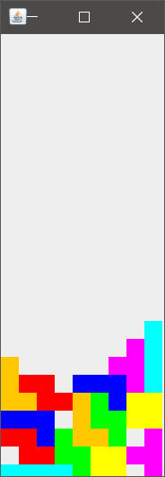

Reflection & Refactor:

For this lab, we successfully created a running java program that displayed various blocks as given by the lab assignment. After learning about JPanel, it may have made it appear cleaner to implement the code and display our blocks inside a panel instead of a frame, but we feel that we did a decent job only using JFrame. We decided not to expand the frame by 20 units in the Y direction to compensate for the JFrame borders, as it may jeopardize some of the given constraints. The issue of clipping could have been avoided by just using a JPanel inside of the JFrame. Throughout the code, we began by just using translations. Later in our code we implemented in an AffineTransform, but never went back to implement it in all the code. Using the AffineTransform proved to simplify the later part of the code by reducing the amount of transformations needed to put each block into place. Implementing it into all the blocks would most likely reduce four to five lines of code. Organization improvements could have been to separate each block into a different section to make it look a little more organized and easier to read, but this change does not affect the program at all. Overall, we are quite happy with our solution to the problem given to us. It meets all the requirements given to us by the problem.

